Student Name: Renaud Bougueng Tchemeube
Student Number: 4333634
5 December 2012

CSI 5387: Data Mining & Concept Learning
Professor: Dr. Stan Matwin

Project Report
Area: Text Classification
Topic: Systematic Reviews in Medicine

OCICS Department – University Of Ottawa @ 2012

Table of Contents
Table of Contents 2
Table of Figures 2
I. General Setup 3
II. Estrogens Dataset 4
Q2.1 Preprocessing 4
Q2.2 Model Building & Results Discussion 5
III. OralHypoglycemics Dataset 6
Q2.1 Preprocessing 6
Q2.2 Model Building & Results Discussion 7
IV. Triptan Dataset 8
Q2.1 Preprocessing 8
Q2.2 Model Building & Results Discussion 8
V. BetaBlockers Dataset 9
Q2.1 Preprocessing 9
Q2.2 Model Building & Results Discussion 9

Table of Figures
Figure 1 – Manual feature removal 5

General Setup
This section briefly presents all general operations done around this project.
      - We have solely used Weka for all the classification tasks.
- About the conversion to CSV files. We have done the following formatting on all datasets using notepad++:
- Replace all “,” by ”;” (“,” are special character of separation for .csv files)
- Remove all “\*\*\*\*\*\* \d+” [document ids]
- Replace all “\r-” by ”,” (Remove all carriage returns)
- Remove all “,---K” (Remove attribute name “K”. “K” represent the class of a given document)
- Remove all “---[A-Z]” (Remove all other attribute names)
- Replace all “_” by ” ” (Separate the MeSH id into meaningful words)
- Add "K,T,A,P,M" at the first line to the file and save as a ".csv"
Applying this sequence of formatting on each dataset returns us a dataset ready for learning.
- We also needed to remove some special characters (% and ") not supported by Weka (failing when we try to open .csv files.
When opening formatted dataset into Weka, we could immediately see that all attributes (K, T, A, P, M) were of type nominal. But, we have as many distinct values as we have instances in the dataset (for each nominal attributes). Therefore, the dataset could hardly be learnt properly. So, we decided to first convert the types of the attributes from nominal to string (except for the class attribute “K”). For that, we built the following weka filter:
weka.filters.unsupervised.attribute.NominalToString -C 2-3,5
This then allowed us to convert the string attributes into Vector/Bag of words. We applied stopword removal (SWR) based on Weka dictionary as well. Because we used slightly different parameter values depending on the datasets, details will be discussed later for each dataset. We also reordered the sequence of attributes so to have the “K” attribute at the end:
weka.filters.unsupervised.attribute.Reorder -R 2-last,first
Weka assigns automatically the last attribute to be the class attribute of a given dataset for the learning task.

Estrogens Dataset

Preprocessing
For the “Estrogens” dataset, we converted all features except the "P" feature and the feature "K" (class of dataset) into String. P had an already interesting distribution where we can clearly see that some publisher values (“P” attribute values) were mentioned in more than one instance of the dataset (meaning that some documents were released under the same publisher). We did not want to lose information that could potentially benefit the learning.
Now, for each string type feature, we tokenize the attribute values and count their occurrences to create bag of words (BOWs). We built the following filter in Weka and applied it on the estrogen dataset:
weka.filters.unsupervised.attribute.StringToWordVector –R 2-3,5 –W 10000 –prune-rate -1.0 –C –N 0 –L –S –stemmer weka.core.stemmers.NullStemmer –M 1 –tokenizer “weka.core.tokenizers.WordTokenizer –delimiters \” \\r\\n\\t.,;:\\\’\\\”()?!\””
This filter also used stopword to eliminate functional common words of the language which are irrelevant for our task. Then we reordered the feature set.
Note that we actually built a MultiFilter w/ those filters for ease of use.
weka.filters.MultiFilter -F "weka.filters.unsupervised.attribute.NominalToString -C 2-3,5" -F "weka.filters.unsupervised.attribute.StringToWordVector -R 2-3,5 -W 10000 -prune-rate -1.0 -C -N 0 -L -S -stemmer weka.core.stemmers.NullStemmer -M 1 -tokenizer \"weka.core.tokenizers.WordTokenizer -delimiters \\\" \\\\r\\\\n\\\\t.,;:\\\\\\\'\\\\\\\"()?!\\\"\"" -F "weka.filters.unsupervised.attribute.Reorder -R 2-last,first"

At this point, our dataset had 7128 features. Because we could not get decent performance with any classifier on this dataset, we decide to reduce the feature set in order to exclude irrelevant attributes; of course, making sure that we can reach at least the same performance with fewer attributes.
We used infogain to rank the attributes and selected all of which had non-zero value for infogain.
Attribute with high infogain are the ones that will well separated the data in a way that isolated the most the class types, thus, facilitating the learning.
AttributeEvaluator = weka.attributeSelection.InfoGainAttributeEval
SearchMethod = weka.attributeSelection.Ranker -T 0 -N -1
We obtained 232 valuable features from the algorithm. So based on those features, we remove all the other ones (except the class "K" of course)
weka.filters.unsupervised.attribute.Remove -V –R
At this point, we see that our dataset also contains some features which are just numbers or irrelevant names and since we are doing a non-semantic task, we can safely discard those as well. Their distributions are non interesting and without impact on the actual model. They were manually removed.
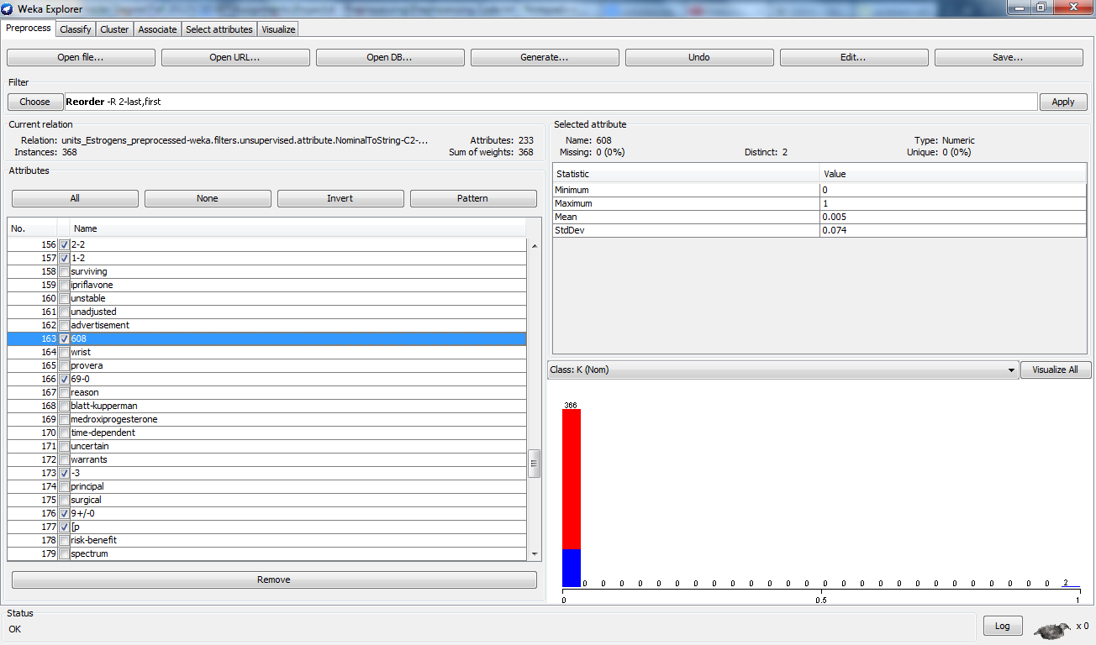
Figure 1 – Manual feature removal
Finally, we end up with a ready-to-mine dataset with the relevant 184 features. Our preprocessing is done. We saved this model for use in experimentation.
File for the preprocessed dataset can be found at this name: units_estrogens_ready.arff

Model Building & Results Discussion
For full results, please refer to the file results_estrogens.arff
We used Weka experimenter to run experimentation with 5x2 cross validation with NaiveBayes, SMO, J48, IBk, RandomForest, AdaBoostM1[w/ NaiveBayes]. Here are our results:
Classifier | AUC (On Average)
NaiveBayes | 0.924783
SMO | 0.7192361
J48 | 0.6593662
IBk | 0.3451303
RandomForest | 0.8501737
AdaBoostM1 (NaiveBayes) | 0.8952256
Table 1 - Classifier performance on Estrogens (AUC)

We can see that NaïveBayes performs quite better than all the other ones. However, a t-test run on the full results shows that NaiveBayes actually performs significantly better than SMO, J48, IBk, RandomForest, but not AdaBoostM1 (w/ NaiveBayes). NaiveBayes overall shows a solid AUC.

OralHypoglycemics Dataset

Preprocessing
For the “OralHypoglycemics” dataset,
We observed that this dataset was highly imbalanced and on the 7 classification labels available.
So, we applied filters to convert the dataset into bag of words (this time for all attributes, except the class attribute “K”),
weka.filters.MultiFilter -F "weka.filters.unsupervised.attribute.NominalToString -C 2-5" -F "weka.filters.unsupervised.attribute.StringToWordVector -R 2-5 -W 10000 -prune-rate -1.0 -C -N 0 -L -S -stemmer weka.core.stemmers.NullStemmer -M 1 -tokenizer \"weka.core.tokenizers.WordTokenizer -delimiters \\\" \\\\r\\\\n\\\\t.,;:\\\\\\\'\\\\\\\"()?!\\\"\"" -F "weka.filters.unsupervised.attribute.Reorder -R 2-last,first"
Now we had too much features (7933) and we need to do feature selection.
We used infogain to rank the attributes and select all of which had non-zero infogain.
AttributeEvaluator = weka.attributeSelection.InfoGainAttributeEval
SearchMethod = weka.attributeSelection.Ranker -T 0 -N -1
As a result, the feature size was trimmed down to 863 attributes.
We tried different classifiers (Ibk, NaiveBayes, J48) on the data without success. The classifier performance gave bad AUC values and were clearly biased. The bias was realistically caused by the imbalanced factor (most examples were classified in the majority class). Dealing with the imbalanced problem, we had two options: work at the dataset level, or at the algorithmic level. We decided to go at the algorithmic level first. So, we tried multinomial naive bayes, SMO, but it did not work. We tried the same process with various subset of the feature set without much success. So, we decide to try out solutions at the dataset using with re-sampling methods on original samples. We chose SMOTE (Synthetic Minority Over-sampling Technique) over other methods like random over-sampling or under-sampling.
SMOTE is proven better than random over-sampling which can cause the learner to over-fit. And under-sampling will make us loose useful information about the dataset that could contribute to the learning. SMOTE generates synthetic examples from nearest neighbours in the dataset. So, we oversampled the number of examples in minority classes in order to bring the sizes to a slightly more reasonable number (e.g. class "7" only had one single example. This makes the learning on that specific class impractical)
Doubling the size of examples labeled "2" from 6 to 12
weka.filters.supervised.instance.SMOTE -C 5 -K 5 -P 100.0 -S 1
Doubling the size of examples labeled "6" from 3 to 6
weka.filters.supervised.instance.SMOTE -C 7 -K 2 -P 100.0 -S 1
Doubling the size of examples labeled "4" from 2 to 4
weka.filters.supervised.instance.SMOTE -C 6 -K 1 -P 100.0 -S 1
Doubling the size of examples labeled "3" from 16 to 32
weka.filters.supervised.instance.SMOTE -C 3 -K 5 -P 100.0 -S 1
Doubling the size of examples labeled "5" from 12 to 24
weka.filters.supervised.instance.SMOTE -C 4 -K 5 -P 100.0 -S 1
So,
size(class “I”)=139, size(class “E”)=325, size(class “3”)=32,
size(class “5”)=24, size(class “2”)=12, size(class “4”)=8, size(class “6”)=6
Now, we are ready for learning.
File for the preprocessed dataset can be found at this name: units_oralhypoglycemics_ready.arff

Model Building & Results Discussion
For full results, please refer to the file results_oralhypoglycemics.arff
We used Weka experimenter to run experimentation with 5x2 cross validation with NaiveBayes, SMO, IBk, J48, RandomForest, Bagging[w/ SMO]. Here are our results:
Classifier | AUC (On Average)
NaiveBayes | 0.679256
SMO | 0.6470449
IBk | 0.6000598
J48 | 0.6056283
RandomForest | 0.7015509
Bagging (SMO) | 0.6998769
Table 2 - Classifier performance on OralHypoglycemics (AUC)

We can see for this dataset that RandomForest shows the best performance with a AUC of 0.702. However, a t-test run on the results shows no significant difference between the performance of the classifiers. This is an interesting result. It is possible that we could not find any significantly good classifier. It is also possible that the classifier performances were somehow all affected by the processing we have done on the dataset.

Triptan Dataset

Preprocessing
For this dataset, we applied the same multifilter from “oralhypoglycemics” dataset to get a bag of words representation of the data. Then, after trying out various classifiers on the data without any success (again due to the fact that the dataset is severely imbalanced), we decided to increase the size of the minority classes (just for the 2 lowest classes so to not introduce too much distortion into the dataset). We first removed irrelevant features by using the regex pattern "\d+" in Weka Explorer to capture all attributes that are just numbers and remove them. Then, we used the gainratio attribute selection with ranker search algorithm. The threshold of 0.05 gives us an early cut of feature set (to 725 attributes).
We applied SMOTE algorithm to oversample minority classes “8” and “1”
weka.filters.supervised.instance.SMOTE -C 9 -K 3 -P 100.0 -S 1
weka.filters.supervised.instance.SMOTE -C 5 -K 5 -P 100.0 -S 1
File for the preprocessed dataset can be found at this name: units_triptan_ready.arff

Model Building & Results Discussion
For full results, please refer to the file results_triptan.arff
We have not been able to get better performance when trying different attribute subset of the feature set. So we just used Weka experimenter to run experimentation with 5x2 cross validation with NaiveBayes, SMO, IBk, J48, RandomForest, Bagging[w/ RandomForest], AdaBoostM1[w/ SMO]. Here are our results:
Classifier | AUC (On Average)
NaiveBayes | 0.7637842
SMO | 0.7285378
IBk | 0.5803537
J48 | 0.6404219
RandomForest | 0.7306401
Bagging (RandomForest) | 0.7781558
AdaBoostM1 (SMO) | 0.7340524
Table 3 - Classifier performance on Triptan (AUC)

We can see for this dataset that Bagging (w/ RandomForest) shows the best performance with a AUC of 0.778. However, a t-test run on the results shows no significant difference between the performance of NaiveBayes, SMO, RandomForest, Bagging (w/ RandomForest) and AdaBoostM1 (w/ SMO). IBk and J48 are shown to perform significantly worse than the others.

BetaBlockers Dataset

Preprocessing
For this dataset, we applied the same multifilter from “oralhypoglycemics” dataset to get a bag of words representation of the data. This resulting dataset had 16218 attributes. With such a number of attributes, it was almost impossible for us to run any learning job on our machine (decent laptop). So, we reduced the size of the feature set. Again, we used the infogain with ranker search algorithm, reducing the feature set to 239 attributes.
AttributeEvaluator = weka.attributeSelection.InfoGainAttributeEval
SearchMethod = weka.attributeSelection.Ranker -T 0 -N -1
Then, after trying out various classifiers on the data without any success (again due to the fact that the dataset is imbalanced), we decided to increase the size of the minority classes.
We used SMOTE to oversample the class "I", "2" and "6" respectively:
weka.filters.supervised.instance.SMOTE -C 2 -K 5 -P 100.0 -S 1
weka.filters.supervised.instance.SMOTE -C 7 -K 5 -P 100.0 -S 1
weka.filters.supervised.instance.SMOTE -C 8 -K 5 -P 100.0 -S 1
We also removed irrelevant features by using the regex pattern "\d+" in Weka Explorer to capture all attributes that are just numbers and remove them.
File for the preprocessed dataset can be found at this name: units_BB_ready.arff

Model Building & Results Discussion
For full results, please refer to the file results_BB.arff
With Weka experimenter, we run experimentation with 5x2 cross validation with J48, NaiveBayes, SMO, IBk, Bagging[w/ SMO], Bagging[w/ NaiveBayes]. Here are our results:
Classifier | AUC (On Average)
J48 | 0.691987
NaiveBayes | 0.7186789
SMO | 0.7502024
IBk | 0.6737251
Bagging (SMO) | 0.7875215
Bagging (NaiveBayes) | 0.7452241
Table 4 - Classifier performance on BetaBlockers (AUC)

We can see for this dataset that Bagging (w/ SMO) shows the best performance with a AUC of 0.788. And a t-test run on the results shows Bagging (w/ SMO) is significantly better than all the other trained classifiers.

